**Card Reference Sheet**

**Combat Types**

**Melee Support Ranged**

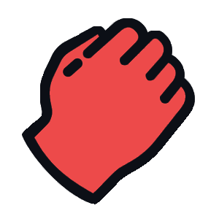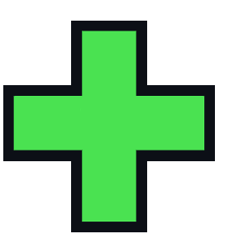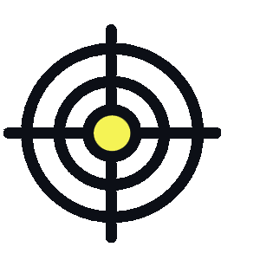

**Movement**

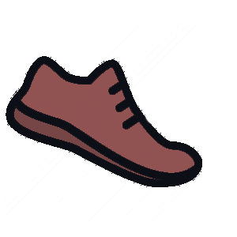

**Grounded -** This unit cannot occupy or move onto the same spaces as enemy units, obstacles, buildings, and the Spawner Hive.

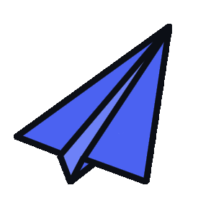

**Flying -** This unit can move over tiles that otherwise restrict **Grounded** units. However, they still may not occupy those tiles at the end of its owner’s turn.

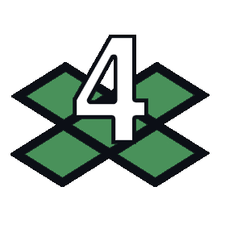

**Speed -** How many tiles the unit can move over per turn.

**Attack Properties**

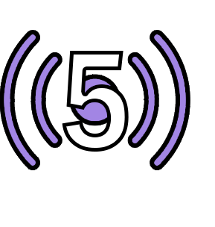

**Attack Range -** How many tiles away the action can hit.

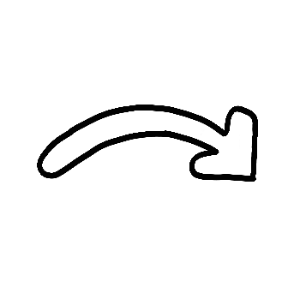

**Arcing -** This action cannot be blocked by obstacles. 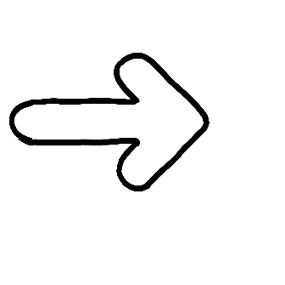

**Straight -** This action can be blocked by entities. If an entity is in the path of the action’s intended target, it receives the attack instead.

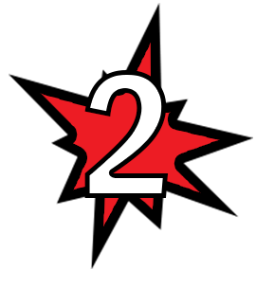

**Damage -** The amount of damage this action does.

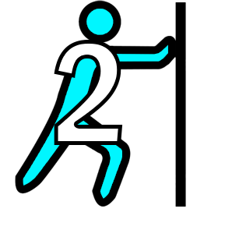

**Knockback -** How many tiles the target is knocked away by this action. The direction of the knockback is the same as the attack’s direction, unless specified on the card.

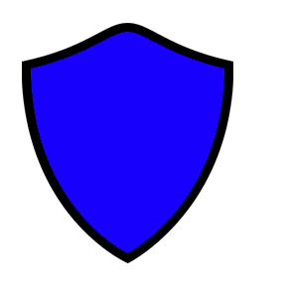

**Shield -** A **Shielded** unit takes 0 damage from the next attack. That attack’s knockback and other effects are also canceled. Upon receiving the attack, the **Shield** is removed.

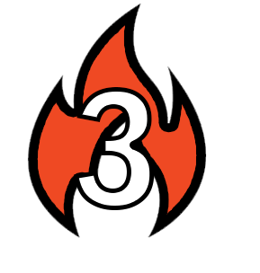

**Burning - Burning** units take 1 damage at the beginning of their owner’s turn. The effect lasts for the indicated number of turns on the symbol.

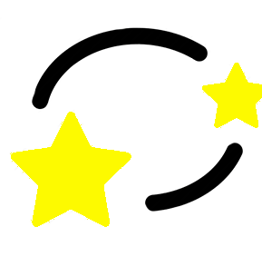

**Stun - Stunned** units cannot move, attack, or perform any other action during its owner’s turn for 1 turn.

**Targetable Area**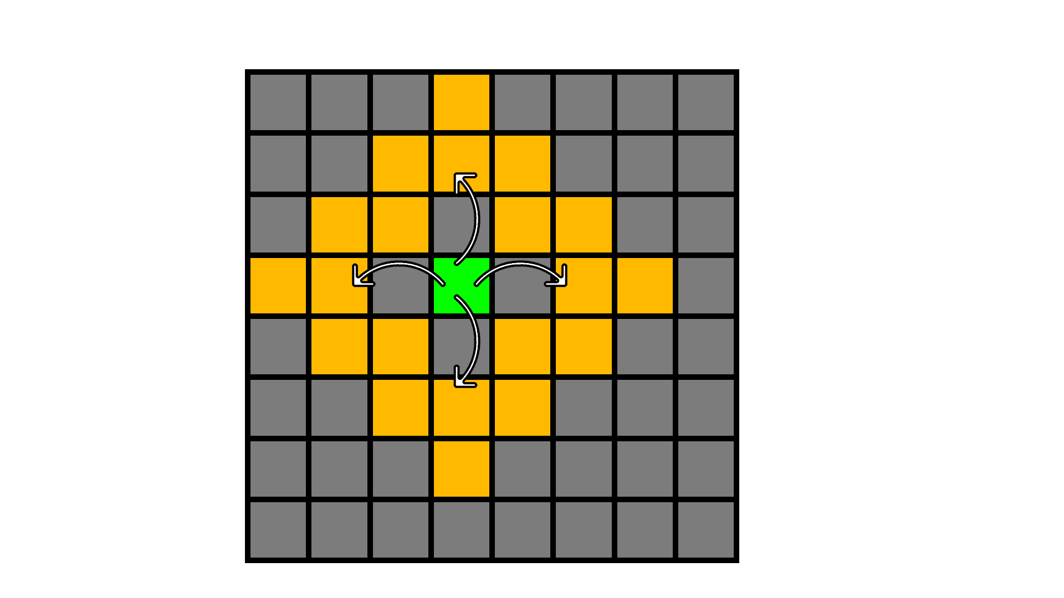

The green square represents the acting entity. The targetable area is shown by the yellow squares. This is generally used by actions that target only one square.

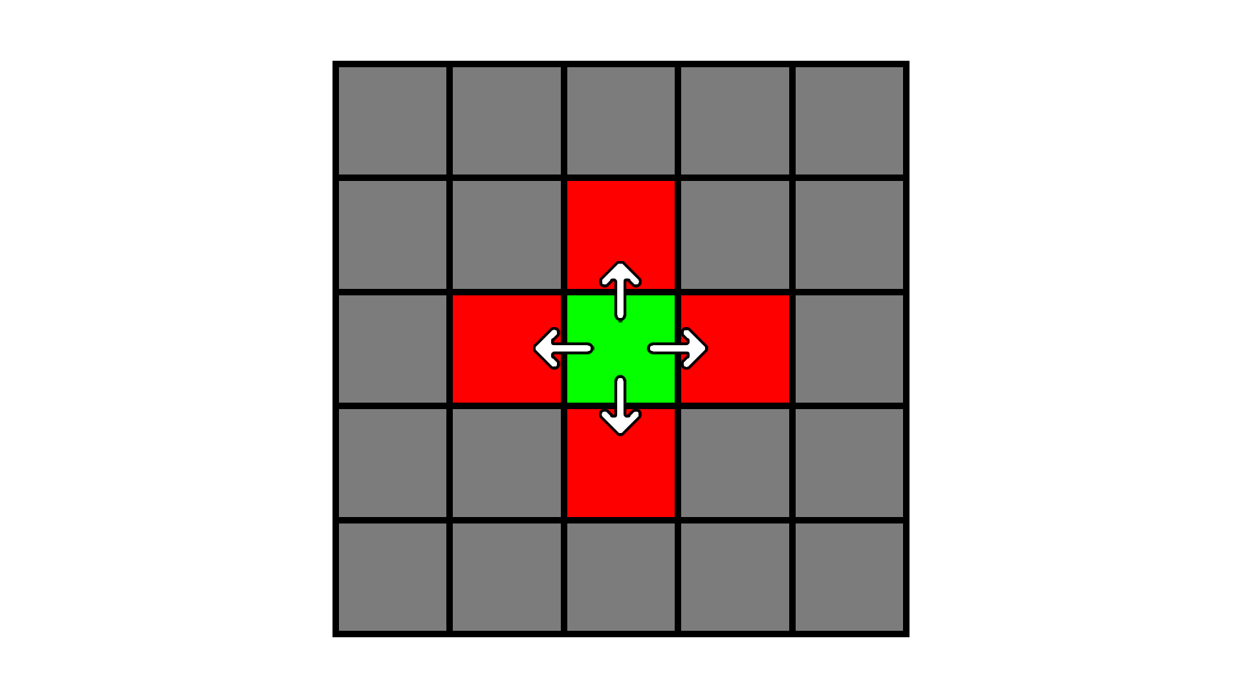

Certain attacks have an **area-of-effect** (AOE), which will use this style of grid. The epicenter of the AOE is represented by the green square, while the AOE is shown in red. Use the action’s **Range** value to determine how far away the epicenter can be targeted from the acting entity.